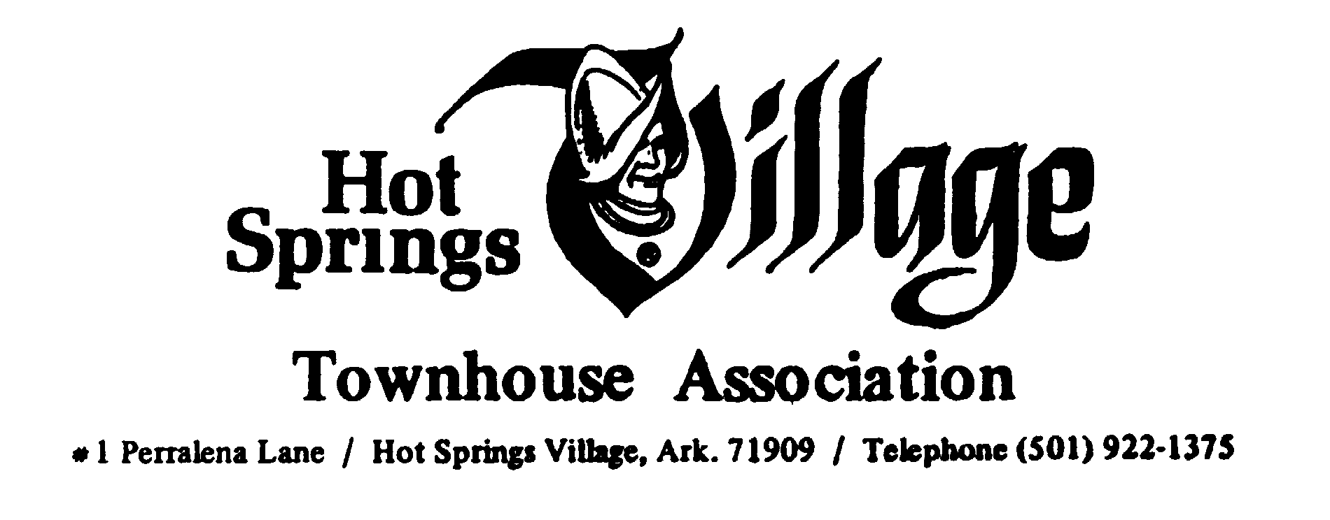
VOTING MEETING OF THE BOARD OF DIRECTORS
Feb 9th, 2023 – 10:00 A.M.
AGENDA
Call to Order

- Invocation
- Quorum
- Reports
  - Secretary – minutes from Dec 2023 Meeting – Motion to Approve
  - Treasurer Report
  - ARC - Motion to accept new members.
    - Mark Sanders – La Coruna
    - Terri Shaw - Desoto
  - SC & C – Melanie Clark – Applications
    - Robert Smith – Valencia
    - Kathe Hudson – Castellon
    - Finance: Ernest Gee
  - GM – Kevin Meacham / Employee Update
  - President’s Report – DeSoto Status – Signs and lighting – Strategic Plan
  - Collections Report – J Huber
  - Define Owners in “Good Standing”
  - By Laws / Rules Committee
- New Business
  - Fees and Structures of Fines – KM - As noted
  - Enforcement of Rules
  - By Laws / Rules Committee
- Motion to adjourn.

